MEMORY MANAGER

Functionality

The purpose of the memory manager is to facilitate access to all the memory locations within the MIPS architecture.

Overall Features

- Flexible maximum and segment memory size
- Ability to read and write to any location in memory by resolving addresses
- Ability to push and pop data from the stack

Use Cases

Various other parts of the system will need to be able to have access to memory through the MM.

Cycle Control Manager

- Reads the text segment of the memory to retrieve the next instruction.
- Reads and writes to memory locations according to how the current instruction executes.

Assembler/Loader

- Will take the symbol table from the AST and write all the variables to the static data section in memory.
- Traverses the AST and writes to the text segment of memory.

Responsibilities

STORE

Given an (Address,Value) pair, the memory manager will store the value at the specified location in memory, error checking that the required address is not outside the practical range of memory.

RETRIEVE

Given an (Address) singleton, the memory manager will retrieve the appropriate value from the location in memory and return it to the calling method.

Design

Memory must be divided up into four segments:

Reserved Memory usually used by the operating system, possibly will be redundant in our system.
Text Memory used to store the machine code for the assembly program itself.
Data Memory used to store the various variables used within the program (resolved from the symbol table constructed along with the AST)
Dynamic The program stack grows downward from the top of memory and the data section can grow upwards.
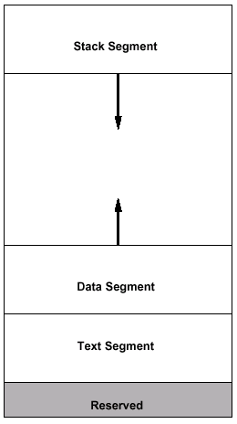

It is clear that the memory manager is essentially a data store with access methods to allow ease of retrieval and storage. Therefore the storage methods need to be considered:

Alternative 1

The first alternative considered was to make the static segments of memory (e.g. Reserved, Text and Data) static data structures like arrays. The remaining dynamic structures would be implemented using coded dynamic data structures. However, this idea was discarded because it would make flexible memory sizes hard to manage, and would take up a lot of memory which would likely not be used.

Alternative 2

The second implementation possibility is to have separate dynamic structures for each of the segments. For example each section can have a separate memory map structure and the MM would work out from a given address which map to examine to retrieve the required value. The possible advantage here is that the

Alternative 3

The final alternative is to have one substantial dynamic data structure to represent memory, and retrieve data from the structure accordingly. This would remove the conceptual segments from the implementation. However, there is a possibility that such a structure could grow to become very large, with the implication of slow access to all areas of memory.

Summary

Alternative 1 has been discarded, as it wastes memory space and also would be tricky to implement since different addresses would require different retrieval methods e.g. one address would mean accessing an array, a different address would mean accessing a dynamic structure.

Alternative 3 would be a perfectly adequate possibility, however it is likely that as the memory increases in size the performance of retrieval will reduce.

Alternative 2 will therefore be chosen as the implementation choice as it gets around this specific issue by breaking up the memory into different chunks. Appropriately, the main issue to be considered during implementation is how choose which structure to examine for specific addresses.

Implementation

The following interface is proposed for the memory manager.

import java.util.TreeMap;

public interface MemoryManagerInterface
{
/* stores a value at the supplied address and returns true if the store was successful, false if a failure */

public boolean store(int address, int value);

/* returns a value at the specified address provided, -1 if the address is out of the bounds of memory */

public int retrieve(int address);
}

Both the address and value variables passed into the memory manager will be integers. The actual implementation of the data storage will be through a Map interface that allows objects to be stored as (Key, Value) pairs. A series of java.util.TreeMap structures representing each of the memory segments will implement this interface. A TreeMap guarantees a log(n) retrieval time where n is the number of items within the store.

A helper method will be able to work out which segment of memory a specific address resides in, and therefore which TreeMap structure to examine. The store and retrieve methods will utilise this method.It is envisaged that the dynamic structures will ‘only’ store non-zero data. Thus if a retrieve is called for an address not in any of the structures, then it is automatically returned as 0.

